LEZIONE 04-21 PT.2
GOOD NIGHT, SLEEP TIGHT.
A Machine Learning Approach to the study of sleep disorders.
SLEEP: reversible neuro-behavioural state of relative perceptual disengagement from and unresponsiveness to the environment.
It’s:
- Physiological state
- Recurring

- Alternating.

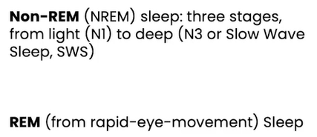

PARADOXICAL SLEEP:
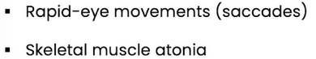

Our cortical activity resembles wake.

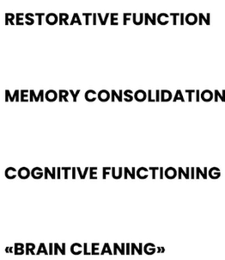
Regular sleep cycles positively impact the quality of life.

BRAIN CLEANING is related with glymphatic system. Has a pivotal function, removing metabolism waste products from the Central Nervous System.
The lymphatic activity is higher during SLOW-WAVE SLEEP, and lower during wakefulness.
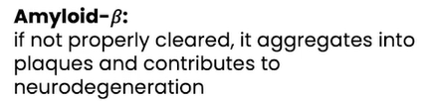

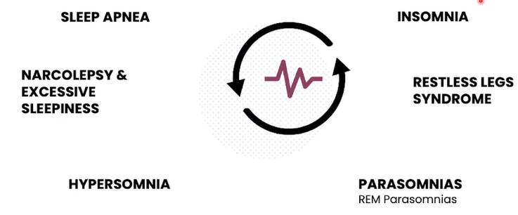

- SLEEP APNEA: choking of air.
- INSOMNIA: remain asleep.
- NASCOLEPSY & EXCESSIVE SLEEPNESS: suddenness sleep attack.
- HYPERSOMNIA: Excessive need of sleeping.
- RESTLESS LEGS SYNDROME: painful sensation of legs.
- PARASOMNIAS: unusual sleep behaviours.

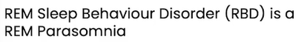
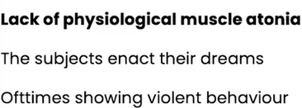

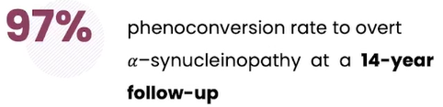
A-synucleinopathy is a family of neurovegetative disorder characterized by an accumulation of a-synuclein in neuros. Is a protein responsible for neurotransmitter release.
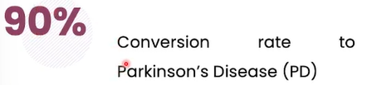
These disorders cost 3 Billion euros in Italy. 10 People worldwide are affected by Parkinson, of which 40% present secondary REM sleep behaviour Disorder (RBD).
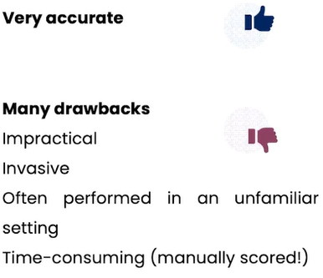
POLYSOMNOGRAPHY is an instrument for diagnosis sleep disorders.

- aim is: MINIMALLY INVASIVE PSG (Polysomnography) & FAST SCORING.
Machine learning techniques can do an automatic sleep staging, through two approaches:
- Hand-engineered features
- Row data-driven.
It’s based on detection of REM sleep behaviour disorder by automated polysomnography analysis.

It’s deep learning in automatic sleep staging with a single channel electroencephalography.
Manual feature extraction approach vs deep network approach.
- Feature-based approached are better for interpretability
- Deep networks do not provide explainability, always look for a trade-off.

- AUTOMATIC RBD DETECTION. Is faster (but reliable) diagnosis.
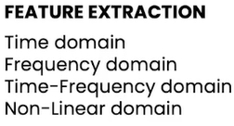
This study tries to discover what happens at cortical level, investigating the contribution of REM sleep and Slow-wave sleep.

- OBJECTIVE OUTCOMES. Low cost, continuous monitoring for personalised follow-up. 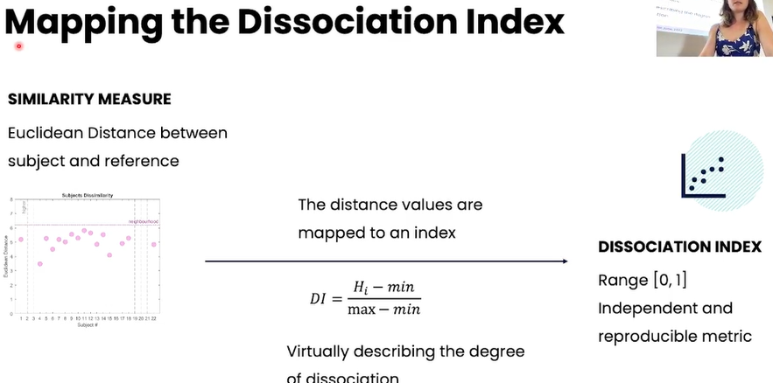
It describes the index of REM dissociation. REM sleep features muscle atonia. When this atonia does not occur, we say that the subject is in a REM DISSOCIATUS state. His brain is in the REM state, but muscle are dissociated than that stage.

